Q&A on how to handle ongoing procedures in relation to mandatory eCTD format
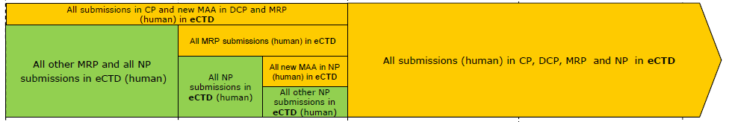
According to the EU eSubmission Roadmap, eCTD format has been mandatory for all MRP submissions (human) since 1 January 2018 and will be mandatory for all submissions (human) in the National Procedures from 1 January 2019.
Questions
- Is the mandatory use of eCTD in MRP/DCP also applicable to submissions for ongoing regulatory activities that started up in NeeS or other non-eCTD formats (e.g. for the responses in ongoing procedures)?
- If so, is this applicable to all submission types, e.g. new MAAs, renewals and variations?
- Is the same handling applicable also for ongoing regulatory activities within National Procedures?
Answer
Yes, the mandatory use of eCTD in MRP/DCP is also applicable to ongoing regulatory activities even if the activity started in non-eCTD format. This applies to all submission types.
This means that submissions related to ongoing activities (e.g. responses or follow up submissions for variations, renewals or new MAAs) should be submitted in eCTD format, even if this means a format shift of the dossier at that time.

On the contrary, for National Procedures (NP), the applicant is recommended to continue to handle ongoing regulatory activities in non-eCTD format, even after the introduction of mandatory eCTD in NP by 1 January.
However, when a new regulatory activity is started within NP after 1 January 2019, it should be submitted in eCTD format and all following submissions for that product dossier should then always be submitted in eCTD format. This would also apply to subsequent submissions for any ongoing procedures concerning the same product dossier.
How to handle related sequences
Applicants are reminded to use the <related-sequence> element in the EU Envelope appropriately for the first and the following submissions for each regulatory activity as stated in the eCTD M1 specification.
However, if the change to eCTD format is done after a regulatory activity has already been started in another format, it would obviously not be possible to use the <related sequence> attribute correctly, since the start of the regulatory activity is not present as an eCTD sequence to refer to (i.e. there will be no ‘initial’ sequence in the lifecycle). In these cases, a technical validation would result in a P/F validation issue (criteria 14.7) and additional aspects need to be considered to avoid technical invalidation with rejection

14.7 | Envelope Attributes | If the submission unit type is not equal to ‘initial’ or ‘reformat' then the entry for related sequence must not be equal to the value for the current sequence. | P/F

In these cases, the documents that started the activity and any updates to the activity that were earlier submitted in other formats should be resubmitted as an eCTD sequence ‘0000’. Then the response (or other follow up) documents for that same activity should be placed in a separate new sequence ‘0001’ and be related to the starting sequence for that activity (‘0000’). It should be clearly stated in the cover letter of the “resubmission sequence” for the ongoing regulatory activity that the content of the previously submitted documents has not been changed, only the format.

Example:
Sequence Number | Submission Description | Submission Type | Related Sequence | Submission Unit Type
0000 | e.g. Resubmission of Type II ASMF update variation | ‘none’ | 0000 | ‘reformat’
0001 | e.g. Response to Type II ASMF update variation | ‘var-type2’ | 0000 | ‘response’
Applicants are also recommended, but not obliged, to move over to eCTD format by submission of a baseline sequence for the current approved dossier. If this is done, the above-mentioned scenario should also be followed for any ongoing regulatory activities in separate sequences.
Example:
Sequence Number | Submission Description | Submission Type | Related Sequence | Submission Unit Type
0000 | e.g. Baseline module 3 | none | 0000 | reformat
0001 | e.g. Resubmission of Type II ASMF update variation | none | 0001 | reformat
0002 | e.g. Response for Type II ASMF update variation | ‘var-type2’ | 0001 | response
A baseline would also be accepted later in the lifecycle. For detailed guidance on that and on baselines in general, please refer to the EU Harmonised Technical eCTD Guidance chapter 2.12.

As for registrations according to article 14 or 16a of Directive 2001/83/EC (simplified registration procedure either for homeopathic medicinal products or traditional herbal medicinal products), the timelines of the eSubmission Roadmap are considered optional. Please refer to regional guidance of the member states.
It is acknowledged that this is a contradiction of the recommendations set out in the Harmonised eCTD technical guidance, where it is stated that the change to eCTD format should preferably be done at the start of a regulatory activity.

